Cuba Dairy Days Royalty Contest Rules

- All participants must be 18 years of age or older or provide consent from a parent or legal guardian.
- All participants must reside in Allegany County.
- All participants must give permission to allow the Cuba NY Chamber of Commerce to publish participant’s name, photo, and charity that they are raising money for.
- All submissions must be received at the Chamber of Commerce office no later than Friday, May 10, 2024.
- The participant’s charity of choice must be announced at the time of submission and their photograph will be taken for promotional purposes.
- Participant’s charity/non-profit of choice should be based locally within Allegany County.
- Participants are responsible for securing their votes. $1 equals 1 vote.
- All votes and monies raised will be turned into the Chamber office by 1:30 pm, Friday, June 7, 2024.
- All monies collected will be donated to the participant’s selected charity in their name.
- The winner will be announced and notified on Monday, June 10, 2024, and crowned Friday, June 14, 2024, at the Dairy Days Street Dance on W Main St, Cuba NY, at a time TBD, winner(s) must be present.
- The winner(s) must participate in the Dairy Days parade, Saturday, June 15, 2024, at 3 pm.

__________________________________ ________________________
Participant’s Signature Date
__________________________________ ________________________
Parent/Legal Guardian Signature Date

______________________________________________________________________________
Name & Address of Charity

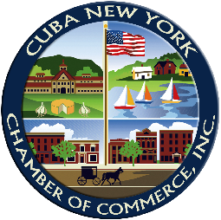

Cuba NY Chamber of Commerce
5 W Main Street
Cuba, NY 14727

